

|  |  |
| --- | --- |
| Date | 10 March 2025 |
| Team ID | PNT2025TMID02614 |
| Project Name | Exploring Cyber Security: Understanding Threats and Solutions in the Digital Age |
| Maximum Marks | 8 Marks |

**List of teammates–**

|  |  |  |  |
| --- | --- | --- | --- |
| **S.no** | **name** | **collage** | **contact** |
| 1 | Tejas Karekar | DYP-ATU | karekartejas62@gmail.com |
| 2 | Sushant Patil | DYP-ATU | Sahilpatil2527@gmail.com |
| 3 | Archit Chougule | DYP-ATU | architchougule@gmail.com |
| 4 | Swarup Dhavan | DYP-ATU | dhavanswarup@gmail.com |

# **INTRODUCTION**

**1.1 Project Name :** Exploring Cyber Security: Understanding Threats and Solutions in the Digital Age

**1.2 Purpose:**

The project aims to analyze cybersecurity threats like malware, phishing, and ransomware while exploring defense mechanisms such as encryption, firewalls, and ethical hacking to enhance digital security.

Abstract:

The purpose of this research study is to investigate the area of cybersecurity threats and related solutions in the age of the internet. Through identifying and examining diverse vulnerabilities, we seek to create an overall picture of the prevalent cybersecurity issues and recommend efficient countermeasures. Vulnerability scanning, threat modelling, and application of security actions focused on safeguarding digital assets will be a part of the research.

Scope of the Project:

The project will entail the identification and examination of cybersecurity vulnerabilities within a target location. It will entail the utilization of tools such as Nessus to scan for vulnerabilities, classify vulnerabilities in order of severity, and give in-depth reports on each vulnerability. The project will also entail an introduction to Nessus, a vulnerability priority chart, and an empathy map to comprehend user views in terms of cybersecurity.

Objectives of the Project:

1. Identify and categorize cybersecurity vulnerabilities existing in a given website.

2. Conduct vulnerability scans with Nessus and generate detailed reports.

3.Evaluate publicly disclosed vulnerability business impact.

4.Suggest possible mitigation measures against each vulnerability.

5. Develop a prioritization chart and empathy map to know and respond to user concerns.

The Thought Behind the Project:

# 2. IDEATION PHASE

**2.1 Thought Behind the Project**

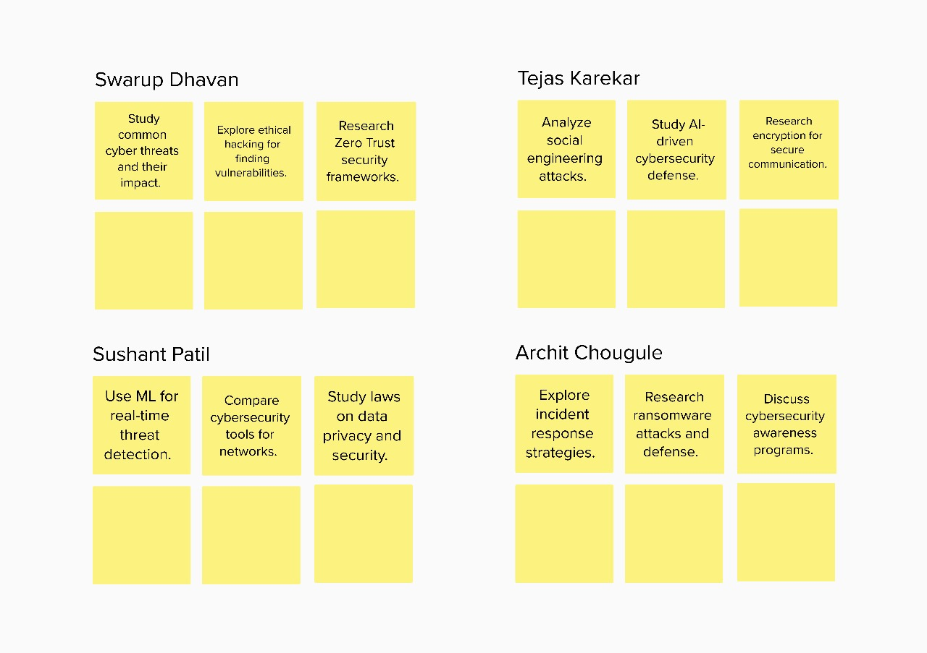

**2.2 Features**

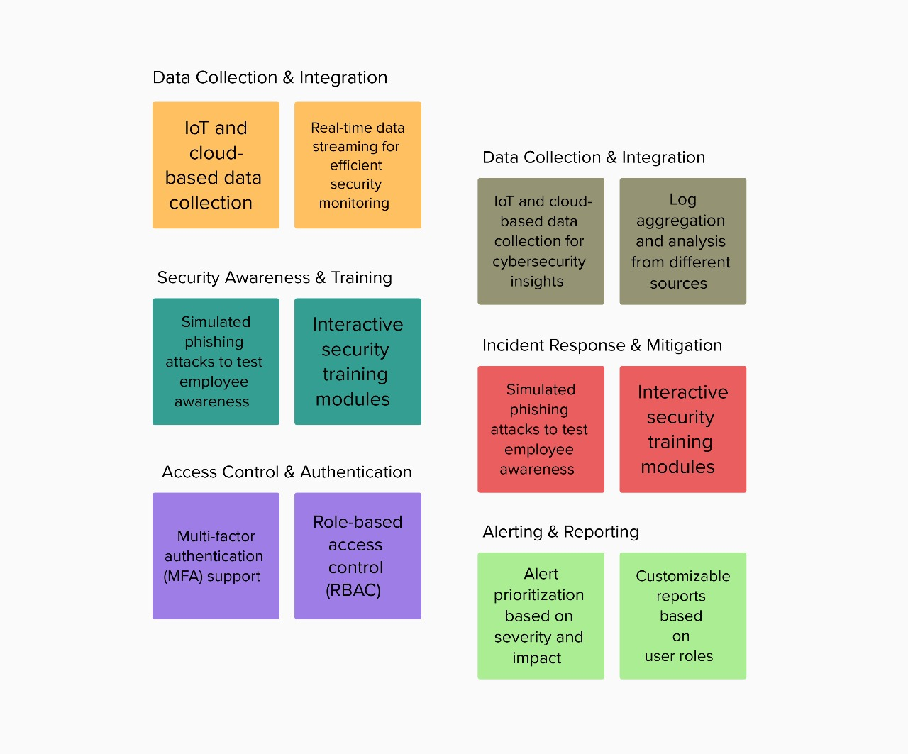

**2.3 Empathy Map**

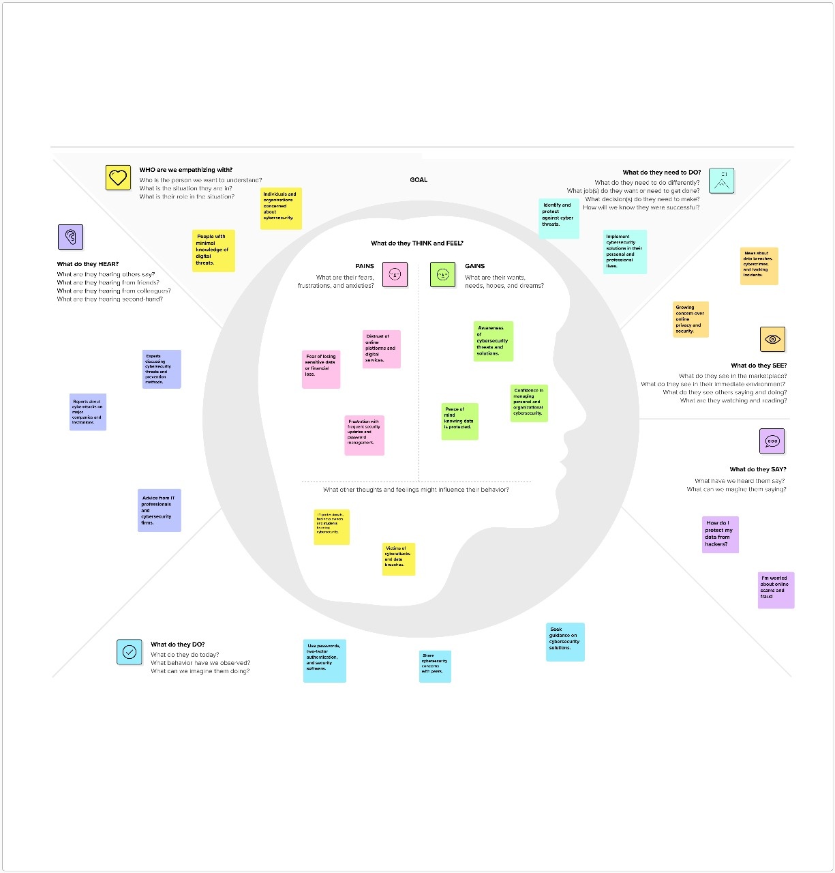

# 3.REQUIREMENT ANALYSIS

**3.1.1 List of Vulnerabilities**

**1)Target website - http://www.itsecgames.com/**

|  |  |  |
| --- | --- | --- |
| **S.no** | **Vulnerability Name** | **CWE - No** |
| 1 | Insecure Direct Object References (IDOR) | 639 |
| 2 | Cross-Site Request Forgery (CSRF) | 352 |
| 3 | Security Misconfiguration | 16 |
| 4 | Unvalidated Redirects and Forwards | 601 |
| 5 | XML External Entity Injection (XXE) | 611 |

**3.2.1 Solution Requirement**

**1)Vulnerability Name:** Insecure Direct Object References (IDOR)

**CWE:** CWE-639

**OWASP/SANS Category:** A01:2021 - Broken Access Control

**Description:** bWAPP has IDOR vulnerabilities where attackers can access restricted data by modifying URL parameters (e.g., changing user_id=123 to user_id=124).

**Business Impact:**

1)Exposure of sensitive user data

2)Unauthorized modifications of records

3)Privacy violations

**How We Found This:**

* Intercepted HTTP requests using Burp Suite.
* Modified the user_id parameter manually and observed if unauthorized data was accessible.
* Successful unauthorized data access confirmed the vulnerability.

**2)Vulnerability Name:** Cross-Site Request Forgery (CSRF)

**CWE**: CWE-352

**OWASP/SANS Category:** A08:2021 - Software and Data Integrity Failures

**Description**: bWAPP lacks CSRF protection, allowing attackers to trick users into executing unwanted actions (e.g., changing passwords) without their knowledge.

**Business Impact:**

* Unauthorized account modifications
* Loss of user control over accounts
* Fraudulent transaction

**How We Found This:**

* Created a malicious HTML form that mimicked a password change request.
* Hosted the form and tricked a logged-in user into submitting it.
* Observed that the request executed successfully without requiring authentication.
* Lack of CSRF token confirmed the vulnerability.

**3)Vulnerability Name:** Security Misconfiguration

**CWE:** CWE-16

**OWASP/SANS Category:** A05:2021 - Security Misconfiguration

**Description:** bWAPP runs with default credentials, has debug mode enabled, and exposes sensitive configuration files.

**Business Impact:**

1)Increased attack surface

2)Exposure of sensitive system information

3)Unauthorized administrative access

**How We Found This:**

* Tried default admin credentials (bee/bug) and successfully logged in.
* Discovered exposed /phpinfo.php, revealing server configurations.
* Found .bak and .txt files through directory brute-forcing using Dirb and Gobuster

**4)Vulnerability Name:** Unvalidated Redirects and Forwards

**CWE:** CWE-601

**OWASP/SANS Category: A10:2021 -** Server-Side Request Forgery (SSRF)

**Description:** Attackers can craft malicious URLs that redirect users to phishing or malware sites by exploiting weak redirect mechanisms in bWAPP.

**Business Impact:**

1)Phishing attacks

2)User credential theft

3)Loss of customer trust

**5)Vulnerability Name:** XML External Entity Injection (XXE)

**CWE**: CWE-611

**OWASP/SANS Category:** A04:2021 - Insecure Design

**Description:** bWAPP improperly parses XML input, allowing attackers to execute SSRF attacks, read local files, or perform denial-of-service attacks.

**Business Impact:**

1)Data exposure (e.g., reading etc/passwd)

2)Server-side request forgery (SSRF)

3)Application crashes due to resource exhaustion

How We Found This:

* Identified redirect.php?url= endpoint.
* Modified the url parameter to point to an external phishing page.
* Sent the crafted link to a test user and observed the redirection.
* No validation of external URLs confirmed the vulnerability.

**5)Vulnerability Name**: XML External Entity Injection (XXE)

**CWE:** CWE-611

**OWASP/SANS Category:** A04:2021 - Insecure Design

**Description:** bWAPP improperly parses XML input, allowing attackers to execute SSRF attacks, read local files, or perform denial-of-service attacks.

**Business Impact:**

1)Data exposure (e.g., reading etc/passwd)

2)Server-side request forgery (SSRF)

3)Application crashes due to resource exhaustion

**How We Found This:**

* Identified an XML input processing feature.
* Sent a malicious XML payload with an external entity to read sensitive files (/etc/passwd).
* Server responded with extracted data, confirming the vulnerability

**2)Target website - https://owasp.org/www-project-juice-shop/**

**3.1.2 List of Vulnerabilities**

|  |  |  |
| --- | --- | --- |
| **S.no** | **Vulnerability Name** | **CWE - No** |
| 1 | Cross-Site Scripting (XSS) | 79 |
| 2 | Cross-Site Request Forgery (CSRF) | 352 |
| 3 | Insecure Direct Object References (IDOR) | 639 |
| 4 | SQL Injection | 89 |
| 5 | Broken Authentication | 287 |

**3.2.2 Solution Requirement**

**1)Vulnerability Name**: Cross-Site Scripting (XSS)

**CWE**: 79

**OWASP/SANS Category:** Injection

**Description:** The OWASP Juice Shop application is vulnerable to Cross-Site Scripting (XSS) attacks. This vulnerability allows an attacker to inject malicious scripts into web pages viewed by other users. The vulnerability was identified in the search functionality of the application, where user input is not properly sanitized or encoded before being reflected in the response.

**How we find:**

By inputting malicious scripts into input fields and observing the reflected output in the web page.

**Business Impact:** If exploited, this vulnerability could lead to unauthorized access to user sessions, theft of sensitive information, and defacement of the website. This could result in reputational damage, loss of customer trust, and potential legal liabilities.

**2) Vulnerability Name:** Cross-Site Request Forgery (CSRF)

**CWE:** 352

**OWASP/SANS Category:** Cross-Site Request Forgery

**Description:** The OWASP Juice Shop application is vulnerable to Cross-Site Request Forgery (CSRF) attacks. This vulnerability allows an attacker to trick a logged-in user into performing unwanted actions on the web application. For example, an attacker could craft a malicious link or script that, when clicked by a logged-in user, performs actions such as changing the user's email address, password, or even making unauthorized purchases.

**How we find:** By crafting malicious links or scripts and observing the actions performed on behalf of a logged-in user.

**Business Impact:** If exploited, this vulnerability could lead to unauthorized actions being performed on behalf of legitimate users, such as changing account settings, making unauthorized purchases, or performing other sensitive actions. This could result in financial loss, reputational damage, and loss of customer trust.

**3) Vulnerability Name:** Insecure Direct Object References (IDOR)

**CWE:** 639

**OWASP/SANS Category:** Authorization

**Description:** The OWASP Juice Shop application is vulnerable to Insecure Direct Object References (IDOR). This vulnerability allows an attacker to access or manipulate objects (such as user data, orders, or other resources) directly by modifying the object's identifier in the URL or request parameters. For example, an attacker could change the user ID in the URL to access another user's profile or order information.

How we find: By modifying the object identifiers in the URL or request parameters and observing the access to unauthorized resources.

**Business Impact:** If exploited, this vulnerability could lead to unauthorized access to sensitive user data, such as personal information, order details, or payment information. This could result in data breaches, loss of customer trust, reputational damage, and potential legal liabilities.

**4)Vulnerability Name**: SQL Injection

**CWE:** 89

**OWASP/SANS Category:** Injection

**Description:** The OWASP Juice Shop application is vulnerable to SQL Injection attacks. This vulnerability allows an attacker to manipulate SQL queries by injecting malicious SQL code into input fields. The vulnerability was identified in the login functionality of the application, where user input is not properly sanitized or parameterized.

**How we find:** By inputting malicious SQL queries into input fields and observing the database responses.

**Business Impact:** If exploited, this vulnerability could lead to unauthorized access to the database, data theft, data corruption, and even complete takeover of the database server. This could result in significant financial loss, reputational damage, and legal liabilities

**5)Vulnerability Name:** Broken Authentication

**CWE:** 287

**OWASP/SANS Category:** Authentication

**Description:** The OWASP Juice Shop application is vulnerable to Broken Authentication. This vulnerability allows an attacker to bypass authentication mechanisms, gain unauthorized access to user accounts, or perform actions on behalf of legitimate users. The vulnerability was identified in the login functionality of the application, where authentication tokens or session management is not properly implemented.

**How we find:** By attempting to bypass authentication mechanisms, such as using weak passwords, exploiting session management flaws, or manipulating authentication tokens.

**Business Impact:** If exploited, this vulnerability could lead to unauthorized access to user accounts, theft of sensitive information, and unauthorized actions being performed on behalf of legitimate users. This could result in financial loss, reputational damage, and loss of customer trust.

**3.3 Technology Stack**

**Tools explored :-**

1. **Nessus** – Used for automated **vulnerability assessment**, Nessus helps identify system misconfigurations, outdated software, and exploitable security weaknesses. It provides detailed reports categorizing vulnerabilities by severity.
2. **OWASP ZAP (Zed Attack Proxy)** – A widely used **penetration testing tool** for detecting vulnerabilities in web applications, including SQL Injection, Cross-Site Scripting (XSS), and broken authentication mechanisms.
3. **Burp Suite** – A powerful **web security testing tool** that allows security professionals to analyze and manipulate web traffic for identifying application vulnerabilities.
4. **Wireshark** – A **network packet analyzer** used for monitoring network traffic, detecting anomalies, and analyzing cyberattacks such as MITM (Man-in-the-Middle) attacks.
5. **Metasploit Framework** – A **penetration testing tool** that enables ethical hackers to exploit known vulnerabilities and assess an organization’s security posture.
6. **Kali Linux** – A **penetration testing and ethical hacking operating system** that includes numerous security testing tools such as Nmap, Hydra, and John the Ripper.

# 4. PROJECT DESIGN

**4.1 Overview of Nessus**

Nessus is a widely used vulnerability scanner designed to identify security weaknesses within a system. It operates by conducting comprehensive security scans across networks, pinpointing vulnerabilities in applications, configurations, and devices. The tool is crucial for ethical hacking, penetration testing, and risk management assessments, helping organizations proactively defend against cyber threats.

**Key Features of Nessus**

* **Automated Scanning**: Nessus performs deep scans on networks and systems to identify known vulnerabilities, misconfigurations, and outdated software.
* **Compliance Auditing**: The tool supports regulatory compliance frameworks such as PCI DSS, HIPAA, and ISO 27001, ensuring that organizations adhere to security standards.
* **Plugin-Based Architecture**: Nessus leverages an extensive plugin library that enables real-time detection of emerging threats and exploits.
* **Configuration Assessments**: It evaluates system configurations to highlight misconfigurations that could be exploited by attackers.
* **Integration with Security Tools**: Nessus can be integrated with SIEM solutions to enhance threat intelligence and incident response workflows.

**Understanding Nessus in Cybersecurity**

Before using Nessus, it is essential to understand its role in vulnerability management and security auditing. Organizations deploy Nessus to conduct routine security assessments, helping to prioritize and remediate vulnerabilities based on severity levels. The tool's ability to generate detailed reports enables security teams to make informed decisions about patch management and system hardening.

Additionally, Nessus plays a critical role in penetration testing, simulating real-world cyberattacks to assess the resilience of an organization's security posture. Security professionals use Nessus to validate security controls, detect potential attack vectors, and reduce exposure to cyber threats.

In summary, Nessus is a powerful tool that enhances an organization's cybersecurity strategy by providing a proactive approach to vulnerability detection and mitigation. Understanding its functionalities and applications is fundamental for effective risk management and threat mitigation in modern digital environments.

**4.2 Proposed Solution**

1. Update & Patch Systems Regularly
2. Enforce Strong Passwords & Enable MFA
3. Close Unnecessary Ports & Secure Configurations
4. Upgrade to TLS 1.2/1.3 & Disable Weak Ciphers
5. Apply Least Privilege Access & Audit Permissions
6. Patch Vulnerabilities & Use Intrusion Prevention
7. Validate Input, Sanitize Data & Use WAF
8. Encrypt Data in Transit & At Rest
9. Harden Settings & Disable Unnecessary Features
10. Use DDoS Protection & Monitor Traffic
11. Regularly Scan & Remove Malware
12. Disable Default Admin Accounts
13. Implement Role-Based Access Control (RBAC)
14. Monitor & Analyze Network Traffic Logs
15. Use Secure VPNs for Remote Access
16. Disable Unused Services & Features
17. Enable Automatic Security Updates
18. Implement Endpoint Detection & Response (EDR)
19. Deploy Host-Based & Network Firewalls
20. Conduct Regular Security Awareness Training
21. Use Anti-Phishing Tools & Email Security Measures
22. Perform Regular Vulnerability Scans & Penetration Tests
23. Implement Secure Boot & BIOS Protection
24. Monitor Privileged User Activities
25. Restrict Access to Sensitive Data
26. Apply Application Whitelisting & Blacklisting
27. Use Sandboxing for Suspicious Files
28. Disable SMBv1 & Use Secure Protocols

**4.3 Understanding of (Exploring Cyber Security: Understanding Threats and Solutions in the Digital Age)**

**Title -** Exploring Cyber Security: Understanding Threats and Solutions in the Digital Age

**1. Cyber Threat Landscape**

The modern cybersecurity landscape is constantly evolving due to the rise of sophisticated cyber threats. From traditional malware to advanced persistent threats (APTs), cybercriminals are leveraging automation, artificial intelligence, and zero-day exploits to bypass security measures. Ransomware attacks have become a major global concern, targeting both individuals and organizations, often demanding cryptocurrency payments for data decryption. Additionally, state-sponsored cyber threats have escalated, posing risks to national security. Understanding these evolving threats is essential to developing robust cybersecurity strategies, implementing proactive threat intelligence, and ensuring strong incident response mechanisms.

**2. Cybersecurity Frameworks and Compliance**

Cybersecurity frameworks provide structured guidelines for securing digital assets. The **NIST Cybersecurity Framework (CSF)** outlines five key functions: Identify, Protect, Detect, Respond, and Recover. **ISO 27001** sets global standards for managing information security, while **CIS Controls** focus on best practices for securing IT systems. Compliance regulations like **GDPR (General Data Protection Regulation), HIPAA (Health Insurance Portability and Accountability Act), and PCI DSS (Payment Card Industry Data Security Standard)** require organizations to adopt stringent security measures to protect user data. Adhering to these frameworks not only reduces cyber risks but also ensures regulatory compliance, avoiding hefty fines and reputational damage.

**3. Web Application Security and OWASP Top 10**

Web applications are a primary target for cyberattacks, with threats ranging from **SQL injection (SQLi) and cross-site scripting (XSS) to security misconfigurations**. The **OWASP Top 10** highlights the most critical web security risks, guiding developers and security professionals in mitigating these vulnerabilities. Secure coding practices, **penetration testing**, and **web application firewalls (WAFs)** are essential in protecting web applications from exploitation. As cloud-based applications become more prevalent, security measures such as **multi-factor authentication (MFA), content security policies (CSP), and API security** play a vital role in reducing cyber risks.

**4. Endpoint and Network Security**

With the rise of remote work and mobile connectivity, endpoint security has become a crucial component of cybersecurity. **Endpoint Detection and Response (EDR)** solutions like **CrowdStrike Falcon and Microsoft Defender ATP** provide real-time monitoring and threat response. **Firewalls, intrusion detection systems (IDS), and intrusion prevention systems (IPS)** enhance network security by filtering malicious traffic. **Zero Trust Network Access (ZTNA)** ensures that no device or user is trusted by default, enforcing strict access controls. As cybercriminals exploit unsecured devices, securing endpoints and networks is vital in preventing unauthorized access and data breaches.

**5. Role of Artificial Intelligence in Cybersecurity**

Artificial intelligence (AI) has transformed cybersecurity by enabling **behavioural analytics, automated threat detection, and anomaly detection**. **User and Entity Behaviour Analytics (UEBA)** leverages AI to detect suspicious activities based on deviations from normal behaviour. AI-driven **Security Information and Event Management (SIEM) solutions** enhance the ability to correlate security incidents in real time. However, AI is also being exploited by cybercriminals for **automated phishing attacks, deep fake social engineering, and AI-powered malware**. As a result, cybersecurity professionals must continuously refine AI-based security measures to counteract evolving threats.

**6. Cloud Security and Zero Trust Architecture**

The adoption of cloud computing has introduced new security challenges, including **misconfigurations, unauthorized access, and insecure APIs**. Cloud security best practices include **encryption, identity access management (IAM), and continuous monitoring**. **Zero Trust Architecture (ZTA)** ensures that no user or device is automatically trusted, enforcing strict access controls based on identity verification. Security solutions like **AWS Security Hub, Microsoft Defender for Cloud, and Google Chronicle** provide centralized security management for cloud environments. As cloud adoption continues to grow, organizations must implement robust security measures to mitigate risks.

**7. Threat Intelligence and Cyber Threat Hunting**

Threat intelligence involves gathering and analysing cyber threat data to prevent potential attacks. Platforms like **MITRE ATT&CK, MISP (Malware Information Sharing Platform), and IBM X-Force Exchange** provide real-time intelligence on known threats. Cyber threat hunting is a proactive approach where security analysts **actively search for indicators of compromise (IoCs) within an organization’s network**. Threat intelligence enhances **incident response, vulnerability management, and risk assessment**, allowing organizations to stay ahead of cyber adversaries.

**8. Incident Response and Digital Forensics**

Incident response is a structured approach to handling security breaches. The **NIST Incident Response Framework** outlines **Preparation, Detection, Containment, Eradication, Recovery, and Lessons Learned** as the key phases of an effective response plan. **Security Operations Centers (SOC) and Computer Security Incident Response Teams (CSIRT)** play a critical role in detecting and mitigating security incidents. Digital forensics involves investigating cyberattacks using tools like **Autopsy, EnCase, and FTK (Forensic Toolkit)** to trace attack origins, analyse malware, and gather evidence for legal proceedings. A well-prepared incident response strategy minimizes downtime and data loss in cyberattacks.

**9. Security Information and Event Management (SIEM) and SOC Operations**

**Security Information and Event Management (SIEM)** platforms aggregate and analyse log data from multiple sources, providing **real-time threat detection and compliance reporting**. **IBM QRadar, Splunk, and ArcSight** are widely used SIEM solutions that help **Security Operations Centers (SOC) detect anomalies, correlate security events, and automate response actions**. SIEM tools enhance **cyber threat visibility, regulatory compliance, and incident investigation**. As cyber threats become more sophisticated, **Next-Gen SIEM solutions with AI-driven analytics** are improving **attack prediction and response capabilities**.

**10. The Future of Cybersecurity: Quantum Computing and Blockchain Security**

Emerging technologies like **quantum computing and blockchain** are reshaping cybersecurity. **Quantum computers** pose a threat to traditional encryption methods, leading to research in **quantum-resistant cryptographic algorithms**. Meanwhile, **blockchain technology enhances security in digital identity management, financial transactions, and supply chain security** by providing **immutable, decentralized, and transparent records**. Future advancements will focus on **post-quantum cryptography, AI-driven security automation, and predictive cybersecurity analytics** to counteract evolving cyber threats.

# 5. PROJECT PLANNING & SCHEDULING

**5.1 Project Planning**

**Project Planning Phase**

**Project Planning Template (Product Backlog, Sprint Planning, Stories, Story points)**

|  |  |
| --- | --- |
| Date | 10 March 2025 |
| Team ID | PNT2025TMID02614 |
| Project Name | Exploring Cyber Security: Understanding Threats and Solutions in the Digital Age |
| Maximum Marks | 8 Marks |

**Product Backlog, Sprint Schedule, and Estimation (4 Marks)**

Use the below template to create product backlog and sprint schedule

|  |  |  |  |  |  |  |
| --- | --- | --- | --- | --- | --- | --- |
| **Sprint** | **Functional**  **Requirement (Epic)** | **User Story**  **Number** | **User Story / Task** | **Story Points** | **Priority** | **Team**  **Members** |
| Sprint-1 | Cyber Threat Identification | USN-1 | As a cybersecurity researcher, I can identify and categorize different types of cyber threats (malware, phishing, ransomware). | 4 | High | Swarup Dhavan |
| Sprint-1 |  | USN-2 | As a security analyst, I can research recent cyber-attack case studies and document their impact. | 3 | High | Archit Chougule |
| Sprint-2 | Digital Forensics & Analysis | USN-3 | As an incident responder, I can analyse logs and extract key insights from compromised systems. | 4 | High | Tejas Karekar |
| Sprint-2 |  | USN-4 | As a forensic analyst, I can investigate and trace the origin of an attack using forensic tools like Autopsy | 3 | Medium | Sushant Patil |
| Sprint-3 | Cybersecurity Defence Mechanisms | USN-5 | As a security engineer, I can implement basic encryption methods (AES, RSA) to protect sensitive data. | 4 | High | Swarup Dhavan |
| Sprint-3 |  | USN-6 | As a developer, I can set up multi-factor authentication (MFA) in a demo application. | 3 | Medium | Tejas Karekar |
| Sprint-4 | Network Security & Monitoring | USN-7 | As a security analyst, I can analyse network packet data using Wireshark. | 3 | Medium | Sushant Patil |
| Sprint-4 |  | USN-8 | As a cybersecurity educator, I can create awareness material on social engineering attacks. | 3 | High | Archit Chougule |
| Sprint-5 | Security Awareness & Best Practices | USN-9 | As a cybersecurity educator, I can create awareness material on social engineering attacks. | 3 | High | Swarup Dhavan |
| Sprint-5 |  | USN-10 | As an end user, I can learn best security practices to protect my personal data online. | 2 | Medium | Tejas Karekar |

**Project Tracker, Velocity & Burndown Chart: (4 Marks)**

|  |  |  |  |  |  |  |
| --- | --- | --- | --- | --- | --- | --- |
| **Sprint** | **Total Story Points** | **Duration** | **Sprint Start Date** | **Sprint End Date (Planned)** | **Story Points**  **Completed (as on**  **Planned End Date)** | **Sprint Release Date (Actual)** |
| Sprint-1 | 7 | 4 Days | Feb 22, 2025 | Feb 25, 2025 | 7 | Feb 25, 2025 |
| Sprint-2 | 7 | 4 Days | Feb 26, 2025 | Feb 29, 2025 | 7 | Feb 29, 2025 |
| Sprint-3 | 7 | 3 Days | Mar 1, 2025 | Mar 3, 2025 | 7 | Mar 3, 2025 |
| Sprint-4 | 6 | 3 Days | Mar 4, 2025 | Mar 6, 2025 | 6 | Mar 6, 2025 |
| Sprint-5 | 5 | 3 Days | Mar 7, 2025 | Mar 9, 2025 | 5 | Mar 9, 2025 |

**Velocity:**

To measure the team’s average velocity, use:

**Velocity = Total Story Points Completed / Number of Sprints**

= **(7+7+7+6+5) / 5**  
= **6.4 story points per sprint (approx.)**

**Burndown Chart:**

# 6. FUNCTIONAL AND PERFORMANCE TESTING

**6.1 Vulnerability Report**

Target website - <http://testphp.vulnweb.com/>

Target ip address:- 192.168.1.100

List of vulnerability –

|  |  |  |  |
| --- | --- | --- | --- |
| **s.no** | **Vulnerability name** | **Severity** | **plugins** |
| 1. | Outdated Software | High | 10345 |
| 2. | Open Ports | Medium | 8576 |
| 3. | Weak Encryption | High | 65432 |
| 4. | Zero-Day Exploit Susceptibility | Critical | 78901 |
| 5. | Cross-Site Scripting (XSS) | High | 53866 |

# 7. RESULTS

#### **7.1 Findings and Reports**

REPORT:-

**Vulnerability Name:-** Cross-Site Scripting (XSS)

**severity: -** High

**Plugin:-** OWASP ZAP (Zed Attack Proxy)

**Port :-** 80 (HTTP)

**Description:-** The web application is vulnerable to Cross-Site Scripting (XSS) attacks. This vulnerability allows an attacker to inject malicious scripts into web pages viewed by other users. The vulnerability was identified in the search functionality of the application, where user input is not properly sanitized or encoded before being reflected in the response.

**solution:-**

Implement proper input validation and output encoding to sanitize user input.

Use Content Security Policy (CSP) to mitigate the impact of XSS attacks.

Regularly update and patch the web application to address known vulnerabilities.

Business Impact: If exploited, this vulnerability could lead to unauthorized access to user sessions, theft of sensitive information, and defacement of the website. This could result in reputational damage, loss of customer trust, and potential legal liabilities.

**Business Impact:-**

the business impact of an XSS vulnerability can be severe, affecting financial stability, customer trust, legal compliance, and overall operational efficiency. Addressing such vulnerabilities promptly is crucial to mitigate these risks.

**Analysis of Title:**

The analysis of Exploring Cyber Security: Understanding Threats and Solutions in the Digital Age highlights the growing complexity of cyber threats and the need for robust defence mechanisms. With the rise of malware, phishing, ransomware, and social engineering attacks, organizations and individuals face increasing risks of data breaches and financial losses. Security vulnerabilities often stem from weak authentication, outdated systems, and lack of user awareness. Effective solutions, such as encryption, firewalls, intrusion detection systems, and ethical hacking, play a crucial role in mitigating these threats. Additionally, proactive cybersecurity strategies, regular vulnerability assessments, and continuous user education are essential to strengthening digital security in an ever-evolving threat landscape.

# 8. ADVANTAGES & DISADVANTAGES

**Advantages:**

* Enhanced Awareness of Cyber Threats – The project educates individuals and organizations about various cyber threats like malware, phishing, SQL injection, and cross-site scripting (XSS), helping them understand potential risks.
* Practical Hands-on Experience – By using tools like Nessus, Burp Suite, OWASP ZAP, and IBM QRadar, the project provides real-world cybersecurity testing experience, enhancing technical skills.
* Early Threat Detection & Mitigation – Vulnerability assessment helps identify security flaws in web applications, networks, and systems before attackers exploit them, ensuring proactive defense.
* Integration with Industry Standards – The project aligns with cybersecurity frameworks like OWASP Top 10, MITRE ATT&CK, and NIST, making it relevant for professional use.
* Improved Security Posture – Organizations can implement the suggested security solutions to strengthen their security infrastructure and minimize potential cyber risks.
* Future-Oriented Research – The study covers AI-driven security, quantum cryptography, and blockchain-based security models, helping researchers and businesses prepare for emerging threats.

**Disadvantages:**

* Complexity of Implementation – Understanding and using cybersecurity tools like SIEM, threat intelligence platforms, and penetration testing tools may be challenging for beginners.
* Time-Consuming – Conducting vulnerability assessments, penetration testing, and security analysis requires significant time and expertise, making it difficult for small teams.
* Limited Access to Real-World Threats – The project mostly relies on test environments rather than real-world enterprise systems, meaning some advanced cyber threats might not be fully explored.
* Ethical and Legal Concerns – Conducting security testing on unauthorized systems could lead to legal consequences if not done ethically with proper permissions.
* Constantly Evolving Threats – The cybersecurity landscape is dynamic, and new attack methods emerge daily, making it difficult to maintain up-to-date defenses.
* Resource Intensive – Running security tools and SIEM platforms requires high processing power, storage, and a stable network, which may not be feasible for all users.

# 9. CONCLUSION

**Stage 1: Understanding Web Application Testing**

Web application testing is a critical component of cybersecurity, ensuring that applications are resilient against cyber threats such as **SQL Injection (SQLi), Cross-Site Scripting (XSS), Security Misconfigurations, and Broken Authentication**. Through testing methodologies like **penetration testing, vulnerability scanning, and source code analysis**, we gained insight into how attackers exploit weak web security implementations. Utilizing tools such as **OWASP ZAP, Burp Suite, and automated scanners**, we understood the importance of **secure coding practices, input validation, access control mechanisms, and encryption** in protecting sensitive data. This phase reinforced the necessity of integrating **security in the Software Development Life Cycle (SDLC)** to prevent vulnerabilities before deployment.

**Stage 2: Understanding the Nessus Report**

Nessus is a widely used **vulnerability assessment tool** that helps organizations identify and remediate security weaknesses. By analysing a Nessus-generated report, we learned how vulnerabilities are **categorized based on severity (Critical, High, Medium, Low, Informational)** and how they align with **Common Vulnerabilities and Exposures (CVE) databases**. The report provided valuable insights into **network misconfigurations, outdated software, weak encryption, and missing patches** that could be exploited by attackers. Understanding the **business impact of vulnerabilities** and prioritizing remediation efforts based on **risk assessment and threat intelligence** highlighted the importance of **continuous vulnerability management, patching strategies, and compliance monitoring** in an organization's security posture.

**Stage 3: Exploring Cyber Security: Understanding Threats and Solutions in the Digital Age** The project "**Exploring Cyber Security**: Understanding Threats and Solutions in the Digital Age" highlights the growing importance of cybersecurity in protecting individuals, organizations, and governments from digital threats. By analysing various attack vectors, vulnerabilities, and mitigation strategies, the study emphasizes the need for robust security measures, user awareness, and proactive defence mechanisms. As cyber threats continue to evolve, a multi-layered security approach, combined with ethical hacking, AI-driven threat detection, and strong regulatory frameworks, is essential to safeguard digital assets and maintain privacy.

# 10. FUTURE SCOPE

**Stage 1: Future Scope of Web Application Testing**

Web application testing is expected to evolve significantly as cyber threats become more sophisticated. The future will see greater adoption of **AI-powered security testing tools** that can detect vulnerabilities in real-time, reducing manual effort and improving accuracy. Additionally, **DevSecOps** will become a standard practice, ensuring that security is integrated throughout the **Software Development Life Cycle (SDLC)** rather than being an afterthought. The emergence of **serverless computing, containerization, and API-driven applications** will require advanced security mechanisms to prevent **API abuses, supply chain attacks, and misconfigurations**. Furthermore, **blockchain-based authentication and homomorphic encryption** may redefine how user identity and data security are managed in web applications. Future advancements in **automated penetration testing, behavioral analysis, and machine learning-driven security assessments** will further strengthen web application security.

**Stage 2: Future Scope of Testing Processes**

Security testing processes will continue to evolve with the growing need for **continuous security validation and proactive threat detection**. The integration of **automated red teaming, continuous penetration testing, and AI-driven ethical hacking** will allow organizations to simulate cyberattacks dynamically, improving their defensive strategies. **Quantum computing** poses a major challenge to traditional encryption algorithms, necessitating the development of **quantum-resistant cryptographic techniques**. Additionally, organizations will increasingly rely on **digital twin environments** to test security policies and simulate attack scenarios without exposing their actual infrastructure to threats. Threat intelligence integration with security testing tools will also enhance **real-time risk assessment and vulnerability prioritization**, making security testing an ongoing, rather than periodic, process.

**Stage 3: Exploring Cyber Security: Understanding Threats and Solutions in the Digital Age**

With the rapid advancement of technology, the **future of cybersecurity** will be driven by AI-powered security systems, quantum cryptography, and blockchain-based security models. The increasing adoption of **cloud computing, IoT, and edge computing** presents new security challenges that require adaptive and automated security solutions. Future research can focus on developing **self-healing networks, zero-trust security models, and real-time threat intelligence systems** to counter sophisticated cyber threats. Additionally, integrating cybersecurity awareness into education and corporate policies will be crucial to creating a more secure digital environment.

**Topics explored :-**

1. **Cyber Threat Landscape** – Understanding the evolving nature of cyber threats, including malware, ransomware, phishing, and nation-state attacks.
2. **Web Application Security** – Analyzing common vulnerabilities such as SQL Injection, Cross-Site Scripting (XSS), and security misconfigurations using OWASP Top 10.
3. **Penetration Testing and Ethical Hacking** – Exploring security assessment methodologies and offensive security techniques to identify weaknesses.
4. **Vulnerability Assessment with Nessus** – Learning how to detect and categorize vulnerabilities in IT systems using automated scanning tools.
5. **Security Information and Event Management (SIEM)** – Understanding the role of SIEM platforms like IBM QRadar in detecting, analyzing, and responding to security incidents.
6. **Security Operations Center (SOC) Operations** – Exploring how SOC teams manage real-time threat detection, incident response, and security monitoring.
7. **Threat Intelligence and Cyber Threat Hunting** – Studying intelligence-driven security approaches using frameworks like MITRE ATT&CK and MISP.
8. **Incident Response and Digital Forensics** – Examining the incident response lifecycle and forensic investigation techniques for cyberattacks.
9. **Cloud Security and Zero Trust Architecture** – Investigating security challenges in cloud environments and the implementation of a Zero Trust security model.
10. **AI and Machine Learning in Cybersecurity** – Exploring the impact of artificial intelligence on threat detection, behavioral analytics, and automated security operations.
11. **Blockchain and Cybersecurity** – Understanding the use of blockchain technology in securing transactions, identity management, and data integrity.
12. **Future Trends in Cybersecurity** – Discussing emerging threats and innovations such as quantum-resistant cryptography, AI-driven attacks, and cybersecurity automation.

# 11. APPENDIX

**11.1 GitHub :**

**https://github.com/TejasKarekar/Exploring-Cyber-Security-Understanding-Threats-and-Solutions-in-the-Digital-Age**

**11.2 Project Demo Link :**

**https://drive.google.com/drive/folders/1amMxenvuwUNgD6LZjC7XopbMEC_keraY?usp=sharing**